***C code for Randomised Quick sort***

***Name: Ishanya***

***Roll no: 21329***

***DSA Assignment***

/* Name: Ishanya

Roll number: 21329

DSA Assignment*/

#include <stdio.h>

#include <stdlib.h>

#include <time.h>

int partition(int arr[], int low, int high) {

int pivot = arr[high];

int i = (low - 1);

for (int j = low; j <= high - 1; j++) {

if (arr[j] < pivot) {

i++;

int temp = arr[i];

arr[i] = arr[j];

arr[j] = temp;

}

}

int temp = arr[i+1];

arr[i+1] = arr[high];

arr[high] = temp;

return (i+1);

}

int randomPartition(int arr[], int low, int high) {

int n = high - low + 1;

int pivotIndex = low + rand() % n;

int temp = arr[high];

arr[high] = arr[pivotIndex];

arr[pivotIndex] = temp;

return partition(arr, low, high);

}

void quickSort(int arr[], int low, int high) {

if (low < high) {

int pivot = randomPartition(arr, low, high);

quickSort(arr, low, pivot - 1);

quickSort(arr, pivot + 1, high);

}

}

int main() {

srand(time(NULL));

int arr[1000000];

for (int i = 0; i < 1000000; i++) {

arr[i] = rand();

}

double total_time = 0;

for (int i = 0; i < 100; i++) {

clock_t start_time = clock();

quickSort(arr, 0, 999999);

clock_t end_time = clock();

double cpu_time = ((double) (end_time - start_time)) / CLOCKS_PER_SEC;

total_time += cpu_time;

printf("Time taken by Randomized Quick Sort on run %d: %f seconds\n", i+1, cpu_time);

}

double avg_time = total_time / 100;

printf("Total time taken by Randomized Quick Sort: %f seconds\n", total_time);

printf("Average time taken by Randomized Quick Sort: %f seconds\n", avg_time);

return 0;

}

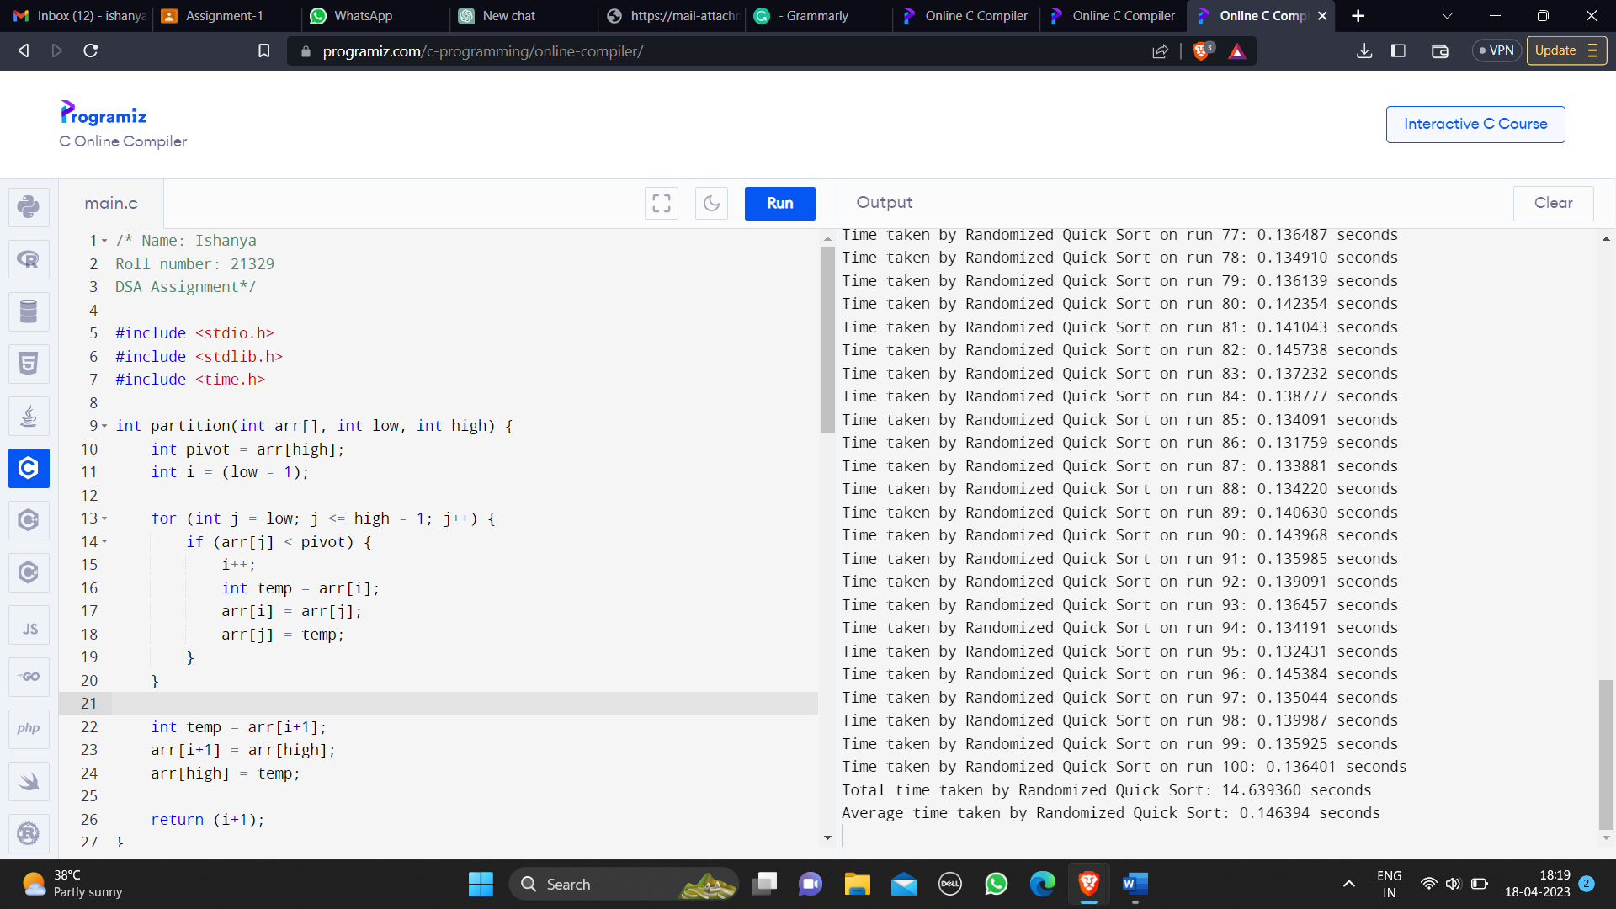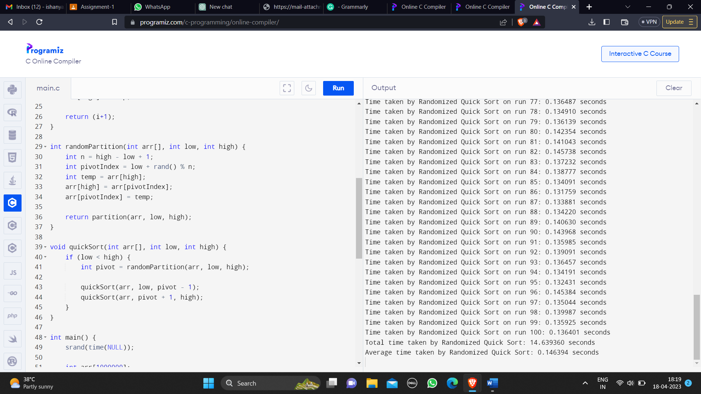

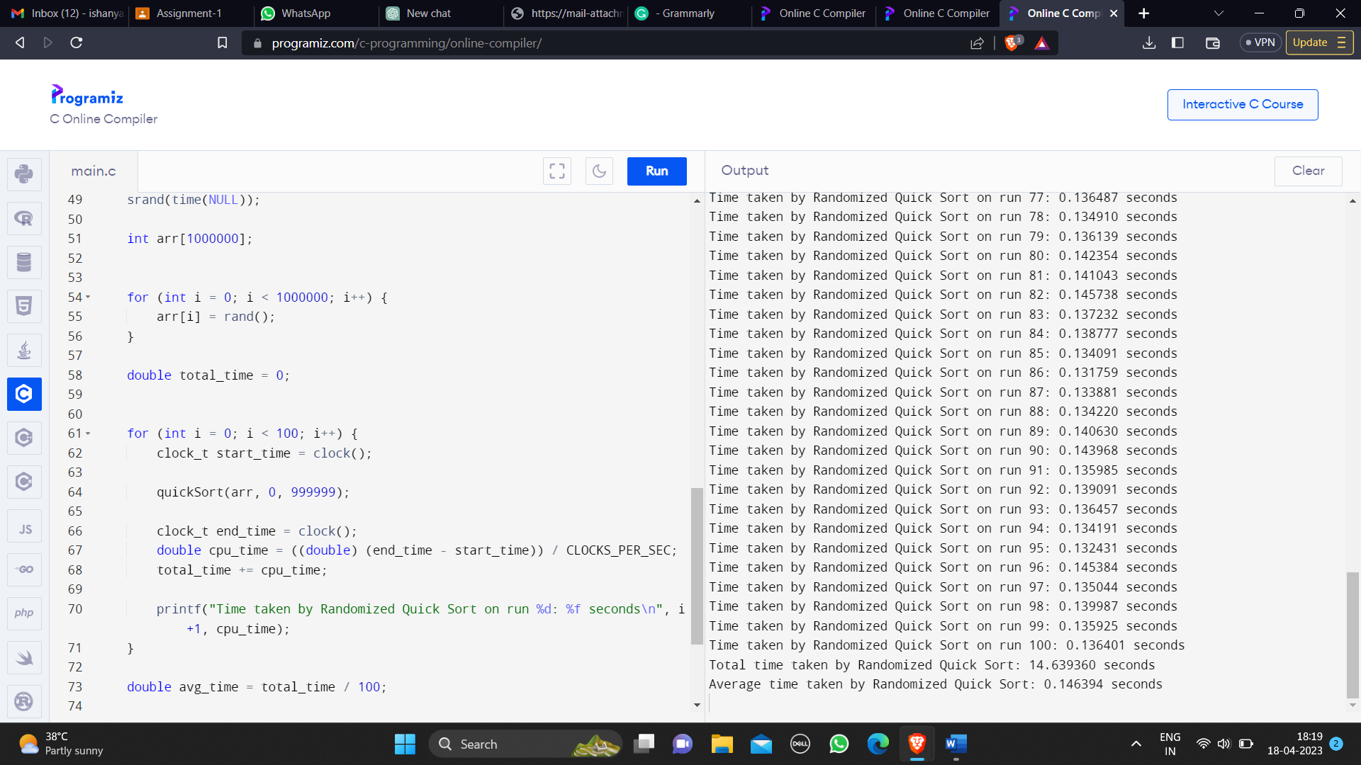

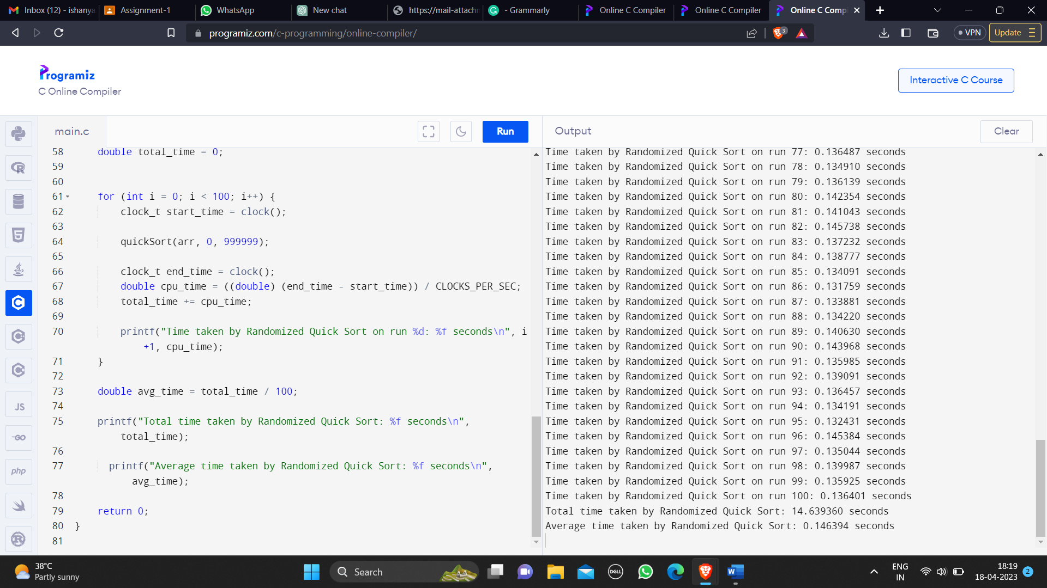

***Report on the CPU time***

Time taken by Randomized Quick Sort on run 1: 0.241264 seconds

Time taken by Randomized Quick Sort on run 2: 0.168704 seconds

Time taken by Randomized Quick Sort on run 3: 0.206001 seconds

Time taken by Randomized Quick Sort on run 4: 0.215197 seconds

Time taken by Randomized Quick Sort on run 5: 0.213897 seconds

Time taken by Randomized Quick Sort on run 6: 0.147570 seconds

Time taken by Randomized Quick Sort on run 7: 0.140974 seconds

Time taken by Randomized Quick Sort on run 8: 0.129307 seconds

Time taken by Randomized Quick Sort on run 9: 0.130733 seconds

Time taken by Randomized Quick Sort on run 10: 0.130822 seconds

Time taken by Randomized Quick Sort on run 11: 0.134338 seconds

Time taken by Randomized Quick Sort on run 12: 0.139421 seconds

Time taken by Randomized Quick Sort on run 13: 0.135814 seconds

Time taken by Randomized Quick Sort on run 14: 0.135721 seconds

Time taken by Randomized Quick Sort on run 15: 0.173138 seconds

Time taken by Randomized Quick Sort on run 16: 0.139797 seconds

Time taken by Randomized Quick Sort on run 17: 0.138410 seconds

Time taken by Randomized Quick Sort on run 18: 0.167320 seconds

Time taken by Randomized Quick Sort on run 19: 0.143515 seconds

Time taken by Randomized Quick Sort on run 20: 0.156757 seconds

Time taken by Randomized Quick Sort on run 21: 0.192383 seconds

Time taken by Randomized Quick Sort on run 22: 0.190582 seconds

Time taken by Randomized Quick Sort on run 23: 0.158666 seconds

Time taken by Randomized Quick Sort on run 24: 0.157722 seconds

Time taken by Randomized Quick Sort on run 25: 0.156605 seconds

Time taken by Randomized Quick Sort on run 26: 0.161397 seconds

Time taken by Randomized Quick Sort on run 27: 0.140382 seconds

Time taken by Randomized Quick Sort on run 28: 0.148549 seconds

Time taken by Randomized Quick Sort on run 29: 0.155349 seconds

Time taken by Randomized Quick Sort on run 30: 0.159124 seconds

Time taken by Randomized Quick Sort on run 31: 0.159683 seconds

Time taken by Randomized Quick Sort on run 32: 0.153120 seconds

Time taken by Randomized Quick Sort on run 33: 0.160881 seconds

Time taken by Randomized Quick Sort on run 34: 0.183903 seconds

Time taken by Randomized Quick Sort on run 35: 0.151653 seconds

Time taken by Randomized Quick Sort on run 36: 0.151645 seconds

Time taken by Randomized Quick Sort on run 37: 0.140129 seconds

Time taken by Randomized Quick Sort on run 38: 0.131999 seconds

Time taken by Randomized Quick Sort on run 39: 0.133198 seconds

Time taken by Randomized Quick Sort on run 40: 0.130952 seconds

Time taken by Randomized Quick Sort on run 41: 0.137647 seconds

Time taken by Randomized Quick Sort on run 42: 0.133980 seconds

Time taken by Randomized Quick Sort on run 43: 0.139465 seconds

Time taken by Randomized Quick Sort on run 44: 0.134108 seconds

Time taken by Randomized Quick Sort on run 45: 0.140331 seconds

Time taken by Randomized Quick Sort on run 46: 0.134915 seconds

Time taken by Randomized Quick Sort on run 47: 0.139938 seconds

Time taken by Randomized Quick Sort on run 48: 0.141224 seconds

Time taken by Randomized Quick Sort on run 49: 0.140027 seconds

Time taken by Randomized Quick Sort on run 50: 0.134120 seconds

Time taken by Randomized Quick Sort on run 51: 0.136420 seconds

Time taken by Randomized Quick Sort on run 52: 0.133211 seconds

Time taken by Randomized Quick Sort on run 53: 0.132399 seconds

Time taken by Randomized Quick Sort on run 54: 0.129063 seconds

Time taken by Randomized Quick Sort on run 55: 0.143332 seconds

Time taken by Randomized Quick Sort on run 56: 0.137719 seconds

Time taken by Randomized Quick Sort on run 57: 0.140022 seconds

Time taken by Randomized Quick Sort on run 58: 0.146662 seconds

Time taken by Randomized Quick Sort on run 59: 0.148254 seconds

Time taken by Randomized Quick Sort on run 60: 0.133678 seconds

Time taken by Randomized Quick Sort on run 61: 0.135686 seconds

Time taken by Randomized Quick Sort on run 62: 0.136837 seconds

Time taken by Randomized Quick Sort on run 63: 0.135144 seconds

Time taken by Randomized Quick Sort on run 64: 0.142320 seconds

Time taken by Randomized Quick Sort on run 65: 0.138593 seconds

Time taken by Randomized Quick Sort on run 66: 0.183504 seconds

Time taken by Randomized Quick Sort on run 67: 0.150268 seconds

Time taken by Randomized Quick Sort on run 68: 0.138135 seconds

Time taken by Randomized Quick Sort on run 69: 0.132399 seconds

Time taken by Randomized Quick Sort on run 70: 0.137143 seconds

Time taken by Randomized Quick Sort on run 71: 0.140061 seconds

Time taken by Randomized Quick Sort on run 72: 0.144740 seconds

Time taken by Randomized Quick Sort on run 73: 0.138031 seconds

Time taken by Randomized Quick Sort on run 74: 0.145485 seconds

Time taken by Randomized Quick Sort on run 75: 0.135641 seconds

Time taken by Randomized Quick Sort on run 76: 0.140111 seconds

Time taken by Randomized Quick Sort on run 77: 0.136487 seconds

Time taken by Randomized Quick Sort on run 78: 0.134910 seconds

Time taken by Randomized Quick Sort on run 79: 0.136139 seconds

Time taken by Randomized Quick Sort on run 80: 0.142354 seconds

Time taken by Randomized Quick Sort on run 81: 0.141043 seconds

Time taken by Randomized Quick Sort on run 82: 0.145738 seconds

Time taken by Randomized Quick Sort on run 83: 0.137232 seconds

Time taken by Randomized Quick Sort on run 84: 0.138777 seconds

Time taken by Randomized Quick Sort on run 85: 0.134091 seconds

Time taken by Randomized Quick Sort on run 86: 0.131759 seconds

Time taken by Randomized Quick Sort on run 87: 0.133881 seconds

Time taken by Randomized Quick Sort on run 88: 0.134220 seconds

Time taken by Randomized Quick Sort on run 89: 0.140630 seconds

Time taken by Randomized Quick Sort on run 90: 0.143968 seconds

Time taken by Randomized Quick Sort on run 91: 0.135985 seconds

Time taken by Randomized Quick Sort on run 92: 0.139091 seconds

Time taken by Randomized Quick Sort on run 93: 0.136457 seconds

Time taken by Randomized Quick Sort on run 94: 0.134191 seconds

Time taken by Randomized Quick Sort on run 95: 0.132431 seconds

Time taken by Randomized Quick Sort on run 96: 0.145384 seconds

Time taken by Randomized Quick Sort on run 97: 0.135044 seconds

Time taken by Randomized Quick Sort on run 98: 0.139987 seconds

Time taken by Randomized Quick Sort on run 99: 0.135925 seconds

Time taken by Randomized Quick Sort on run 100: 0.136401 seconds

***Total time taken by Randomized Quick Sort: 14.639360 seconds***

***Average time taken by Randomized Quick Sort: 0.146394 seconds***

